POSITIONS AVAILABLE

LEADERSHIP CONFERENCE FACILITATOR
2021 Greenhand Leadership Conference

California FFA is seeking to hire Leadership Conference Facilitators to work under the direction of a conference Team Leader and the supervision of the State FFA Leadership Development Coordinator and State Assistant FFA Advisor for the purposes of delivering and coordinating the California FFA Leadership and Personal Growth Development Continuum.
Greenhand Leadership Conferences 2021
A minimum of thirty (30) L1 or L2 Leadership Facilitators and six (6) Team Leaders (see TL app.)
*Number of facilitators may vary with COVID-19 regulations.
Individuals should have experience in public speaking, motivating and/ or mentoring students, classroom or meeting management, be able to take constructive feedback and coaching, and work independently, as well as part of a team. Experience with conference facilitation is preferred.

Please email Application, Resume and Photo in PDF to Miss Garrett at:
hgarrett@californiaffa.org

Send an application worksheet, resume and professional photo by:
Greenhand Leadership Conference 2021
June 21, 2021 *or next business day when this date occurs on weekend/holiday

LEADERSHIP CONFERENCE FACILITATOR (L1 AND L2) DESCRIPTION
Leadership Conference Facilitators (L1 and L2) will be expected to facilitate and deliver conference curriculum to FFA members in a large group, small group or online setting. Facilitators are expected to possess strong knowledge relative to their specific conference and conduct additional research to become prepared. Additional role responsibilities include coaching FFA members, motivating and engaging students, and classroom management (with the exception of student discipline, which is the responsibility of teachers supervising at the conference).

Facilitator position requirements:
- Facilitator Level I (L1) – new to facilitation and/ or having never facilitated at GLC
- Facilitator Level II (L2) – experienced or returning facilitator (GLC, MFE, ALA or SLE)
- Be enrolled in a two or four-year university; staff should not take the semester or quarter off
- Possess excellent public speaking skills; experience in facilitation is preferred
- Experience in managing conferences and/ or students
- Extensive knowledge of Agricultural Education, including Classroom/ Laboratory Instruction, Supervised Agricultural Experience and the National FFA Organization
- Be able to present in business attire
- Be able to multitask and balance a busy schedule that prioritizes educational obligations, family commitments and work for California FFA, as well as social, physical, spiritual and mental needs
- Be able to work independently, as well as a part of a team

General Notes:
- Most GLC conferences are scheduled during September and October over a three to four-day period, typically including Tuesdays, Wednesdays and Thursdays.
  - Staff should plan to miss a minimum of four/five days of school, but as many as eight days with travel depending on conference scheduling, host sites and their classes. The aim is for conferences to take place within the first four weeks of University starting, which reduces the impact of missed days (for those at a UC or Poly, this may be before courses begin).
- Staff should consider modifying their academic schedule to allow for free days or flexible courses. Staff should communicate with instructors to notify them in advance of their absence; they will receive a letter from the state describing the responsibilities of this opportunity that can assist with missing school.
The Team Leader will mentor and provide guidance on creating work/ academic life balance.

COMPENSATION
- Greenhand Leadership Conference (GLC)
Level I (L1) @ 150/conf. Level II (L2) @ 175/conf. Team Leader (T1/T2) @ 200/conf.
- Training Stipend
Facilitator @ TBD; approx. 50/day Team Leader @ TBD; approx. 50/day

- Travel, lodging and meal expenses will be paid as per state association guidelines
- Official uniform (button up shirt) and nametag will be provided
MAJOR RESPONSIBILITIES BY CONFERENCE

GREENHAND LEADERSHIP CONFERENCE (GLC)
Contract: July 1, 2021 to November 1, 2021 L1 (New Staff) and L2 (Returning Staff)
Approx. 7:30 am to 3:30pm (8 hours) + setup/re-set/teardown

Introduces students to Agricultural Education, including SAE opportunities and how FFA will develop them as young leaders. This conference is the “hook-line-and-sinker” to get students to buy into Agricultural Education throughout their four years in high school. | 180-200 freshmen per conference

General major responsibilities include, but are not limited to the following:
- Review curriculum, content resources and texts, and video footage to prepare for training
- Participate in summer large group training seminar: *If COVID-19 ALLOWS
  - Large Group Training: Tuesday, July 27 – Monday, August 2, 2021 – Required Dates
- Facilitate five to six conferences, but never more than seven; typically held at, at least, two different sites

  - Supply Loading
  - Conference set up
  - Facilitate conference (8a to 3p)
  - Conference tear down
  - Evaluate and reflect
  - Supply Unloading

Example conference timeline (not actual conference dates)
- SEPTEMBER
  - W1 – NA
  - W2 – Labor Day (Mon)
  - W3 – Poly/ UC System Starts; Team 1 (Wed, Thu)
  - W4 – Team 2 (Tues, Wed, Thu); Team 3 (Wed)
- OCTOBER
  - W1 – Team 2 (Tue, Wed); Team 1 (Wed, Thu, Fri)
  - W2 – Team 4 (Tue, Wed, Thu, Fri); Team 3 (Tue, Wed, Thu, Fri)
  - W3 – Team 5 (Tue, Wed, Thu, Fri); Team 3 (Tue, Wed, Thu)
  - W4 – NA
  - W5 - National FFA Convention

COVID-19 Disclaimer
As the world begins to heal and more forward, we will continue to watch CDC, US and California regulations and suggestions about handling in-person events.
We are currently reaching out to past GLC sites and seeing who throughout California are looking to book an in-person conference for September or October of 2021. Once we know how many sites we have, we will hire the number of staff needed.
Below there is an option to choose online or in-person conferences. This is only there in case the worse happens and we have to hold online conferences. Choose both if you are interested in working on staff regardless of what might happen in the coming months.

APPLICATION INSTRUCTIONS
- Completed official Application Worksheet, included in the position job posting.
- Resume
- Resumes will be reviewed to determine facilitation, teaching and speaking experience:
  - Prioritize experiences listed on your resume to appropriately identify these areas
- Provide three references that possess knowledge of your experience in facilitation, teaching and public speaking with appropriate contact information and your relationship.
- Phone Interview
- Phone interviews will be conducted to determine work ethic, ability to connect with students and motivation for facilitating conferences.
  - Phone interviews will only be done over the phone. I.e. Not over a form of video chat.
- A phone interview sign-up sheet will be sent out to applicants after the due date of applications.
  - Depending on the number of applicants, a paper screening may take place prior to phone interviews.
- Professional Photo
- The professional photo will only be used to put a face to the name during phone interviews.
- The photo should be from the shoulders up with the applicant in at least business casual attire.
  - Examples of photos: senior photos, photos from previous work experience, job fair head shots etc.

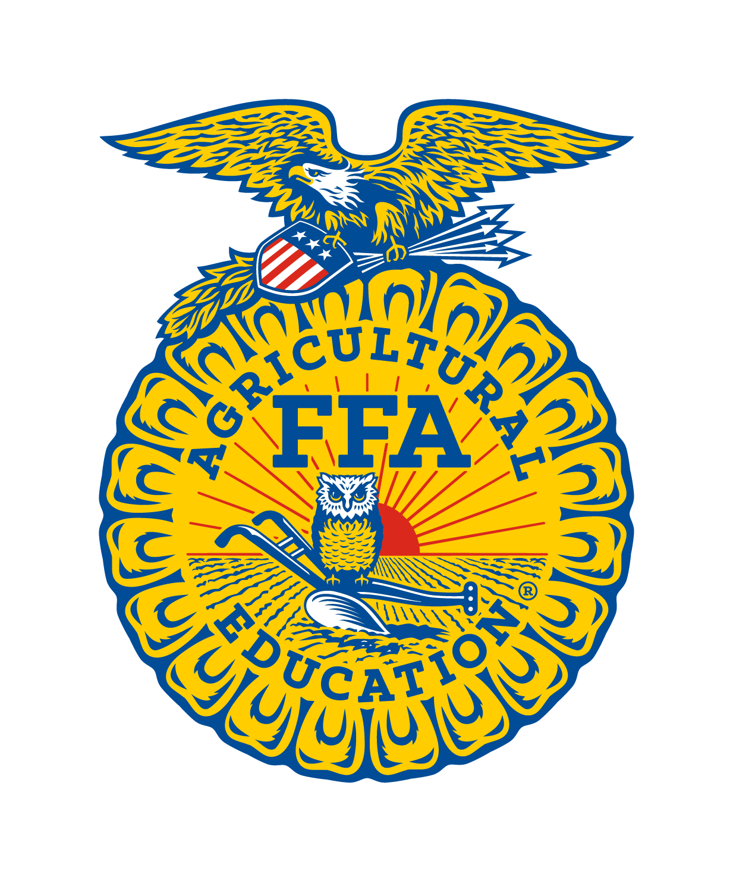 | CALIFORNIA FFA  LEADERSHIP CONFERENCE FACILITATOR  2021-2022
APPLICATION WORKSHEET

This form must be submitted with your resume and professional photo.

Name:

Cell Phone:

Email:

Hometown and FFA Chapter:

College Attending during Conference Season:

Check the description which best matches your level of experience and interest:
Facilitator Level I (L1) – new to facilitation and/or have never facilitated GLC
Facilitator Level II (L2) – experienced or returning facilitator (GLC, MFE, ALA or SLE)

Greenhand Leadership Conference 2019 (L1 or L2)

Conference Type interested in facilitating *page 3
In-Person
Online

As a facilitator, you will be asked to interact with students from a variety of backgrounds and with an array of interests. Why should California FFA entrust you with their students?

What, if any, scheduling conflicts will you have during the conference season? (This will be used to help with team placement and conference date assignments. Please be specific.)

