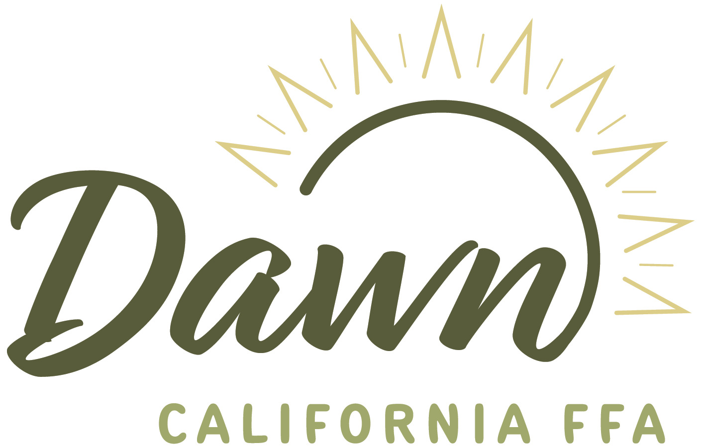

State Award Finalists
Star Farmer
- Madyden Dietz, Merced-El Capitan
- Addison Terhune, Healdsburg
- Lauren Silveira, Chowchilla
- Maria Rivera, Gonzalez
- Thomas Woliung, Lakeside-El Capitan
- Joseph Schohr, Gridley

Star Small Farmer
- Gauge Goehring, Galt
- Jacob Zuniga, St. Helena
- Tyler Joseph Harris, Chowchilla
- Lauren Larsen, Pine Valley-Mountain Empire
- Wyatt Joseph, Marysville

Star in Agriculture Placement
- Peyton Heermance, Altaville-Bret Harte
- Anakaria Hernandez, St. Helena
- Ethan Montejano-Toro, Madera
- Briley Bowen, Paso Robles
- Brody Burnett, Holtville
- Conrad Burrow, Wheatland

Star in Agriculture Business
- Baylor Bloom, Gustine
- Grace Doherty, Woodland-Woodland Christian
- Fernando Bobadilla Navia, Madera
- Lucy Lamping, Fullerton-Sunny Hills
- Kenzie Garramore, Sutter
Star Agriculture Science
- Annika Don, Elk Grove
- Riley Piehl, Santa Rosa
- Adrian Figueroa, Gilroy
- Charlie Cobb, Lakeside-El Capitan
- Taylor Bogle, Sutter

Golden Owl Award
- Shelby Fishman, Atwater
- Robyn Payne, Cresent City-Sunset
- Jennifer Knight, Clovis-East
- Russell Zimmerman, Nipomo
- Tara Meade, Lakeside-El Capitan
- Heather Thomas, Colusa

Star Administrator
- Rick Ryan, Turlock-Turlock Christian
- Tyler Milsap, Davis
- Michael Burchett Jr, Woodlake
- Charlotte Vega, Greenfield
- Amanda Galliano, San Jacinto
- Luke Browning, Grass Valley-Nevada Union

Star Counselor
- Silvia Vargas, Newman-Orestimba
- Joleen Logan, Potter Valley
- Wendy Ward, Bakersfield-Foothill
- Veronica Alfaro, Gilroy
- Ruben Macias, Holtville
- Rebecca Gillespie, Nicolaus-East Nicolaus

Star Supporting Staff
- Dawn Jester, Merced
- Kate Diezel, Esparto
- Clay Freeman, Bakersfield-Foothill
- Maryann Mukai-Clements, Gilroy
- Jennifer Connor, Phelan-Serrano
Premier Chapter Promotion Award
- Mariposa
- Eureka
- Firebaugh
- Gilroy
- Lakeside-El Capitan
- Grass Valley-Bear River

National Chapter Award Finalist

Growing Leaders Finalists
- El Centro Southwest
- Palmdale
- Elk Grove
- Galt- Liberty Ranch

Strengthening Agriculture Finalists
- Visalia-VTEC
- Hanford
- Bakersfield Highland
- Lone Pine

Building Communities Finalists
- Salinas-Everett Alvarez
- Davis
- Firebaugh
- Elk Grove

