

1

2020 Virtual State Conference

All In

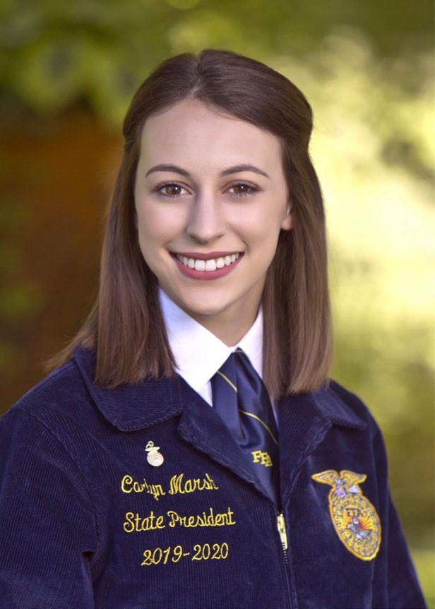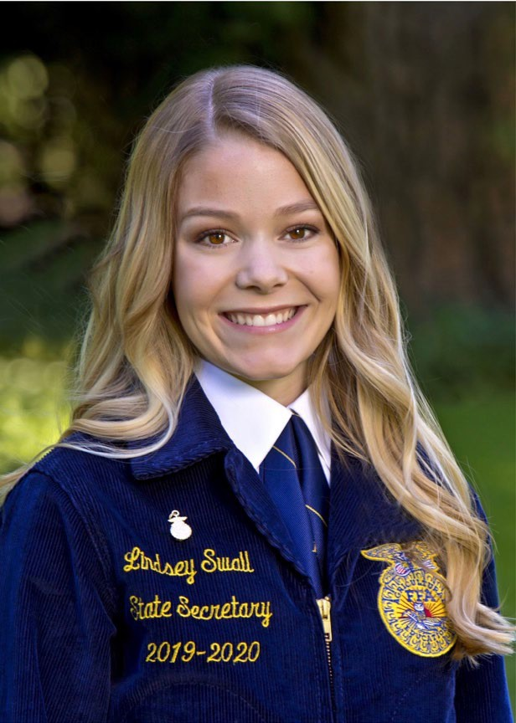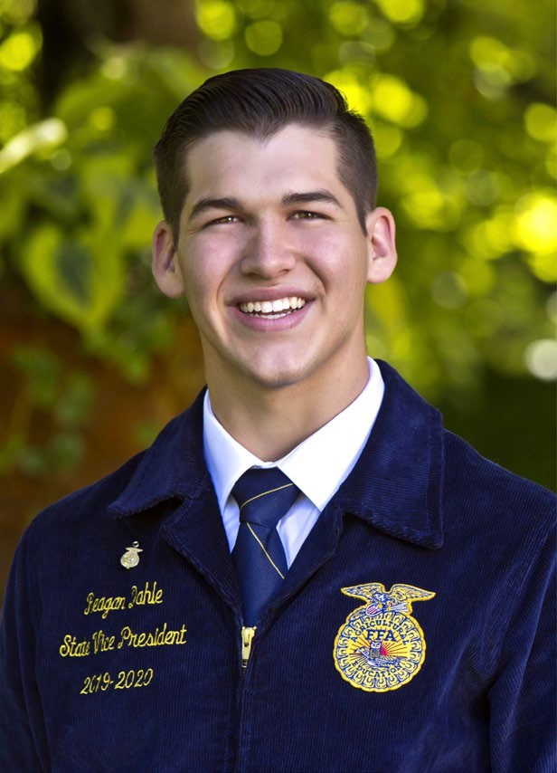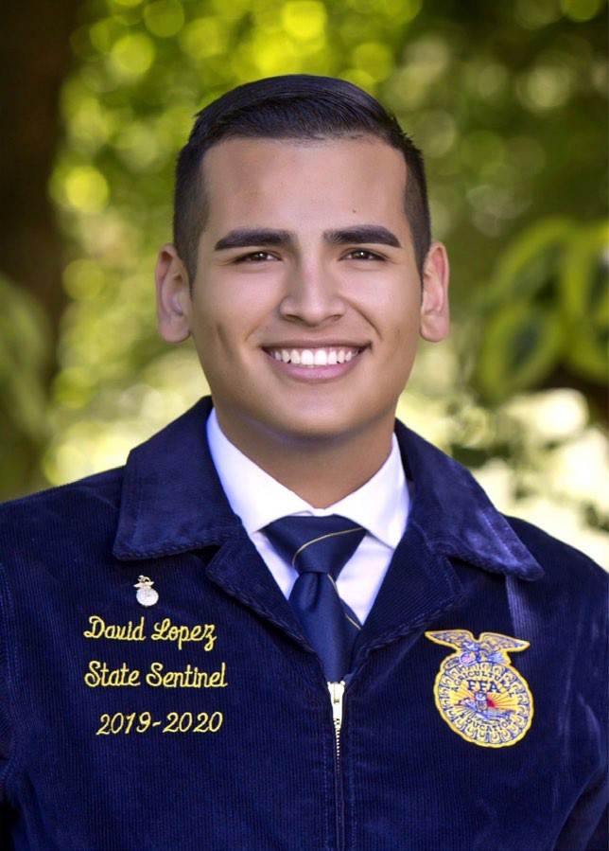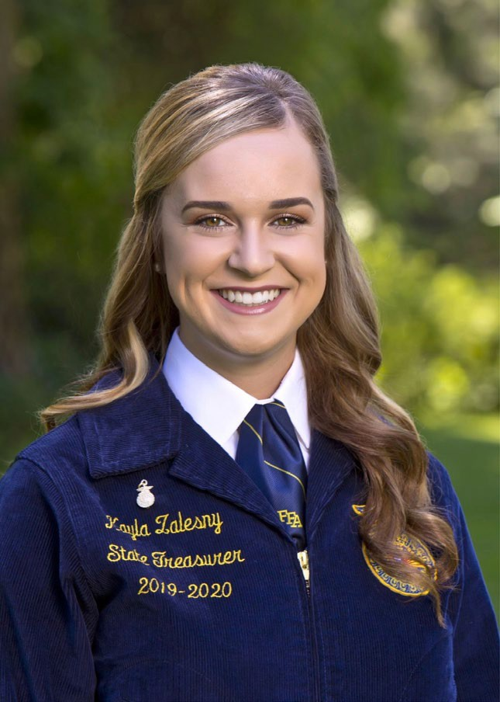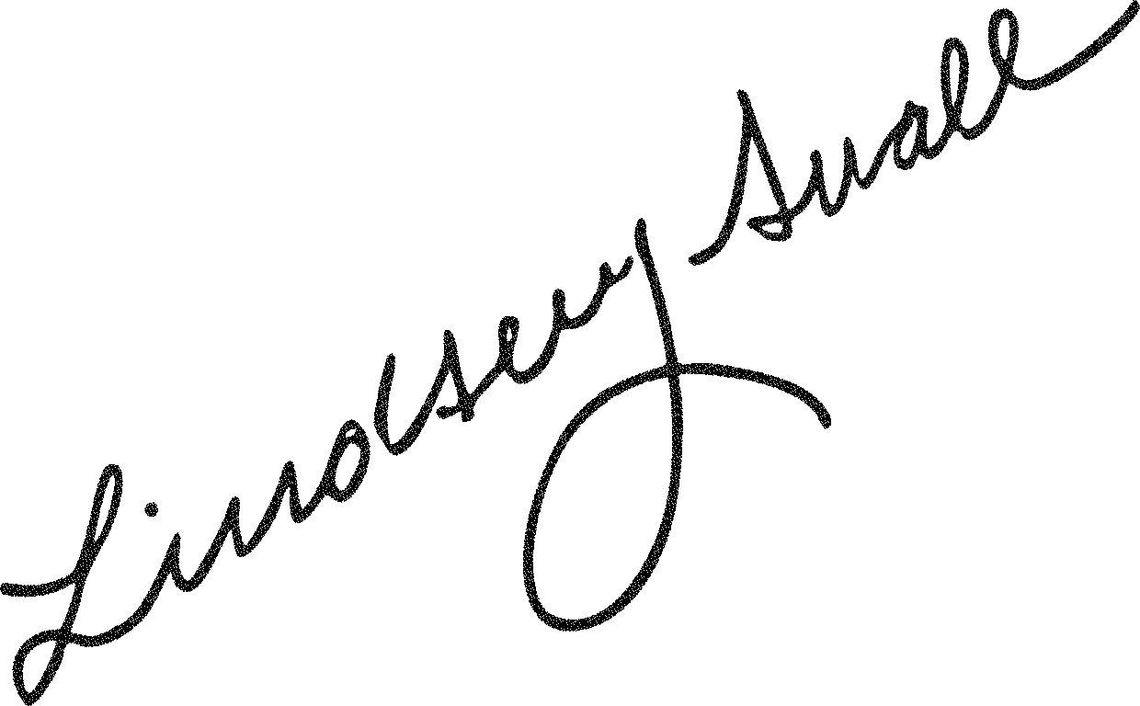

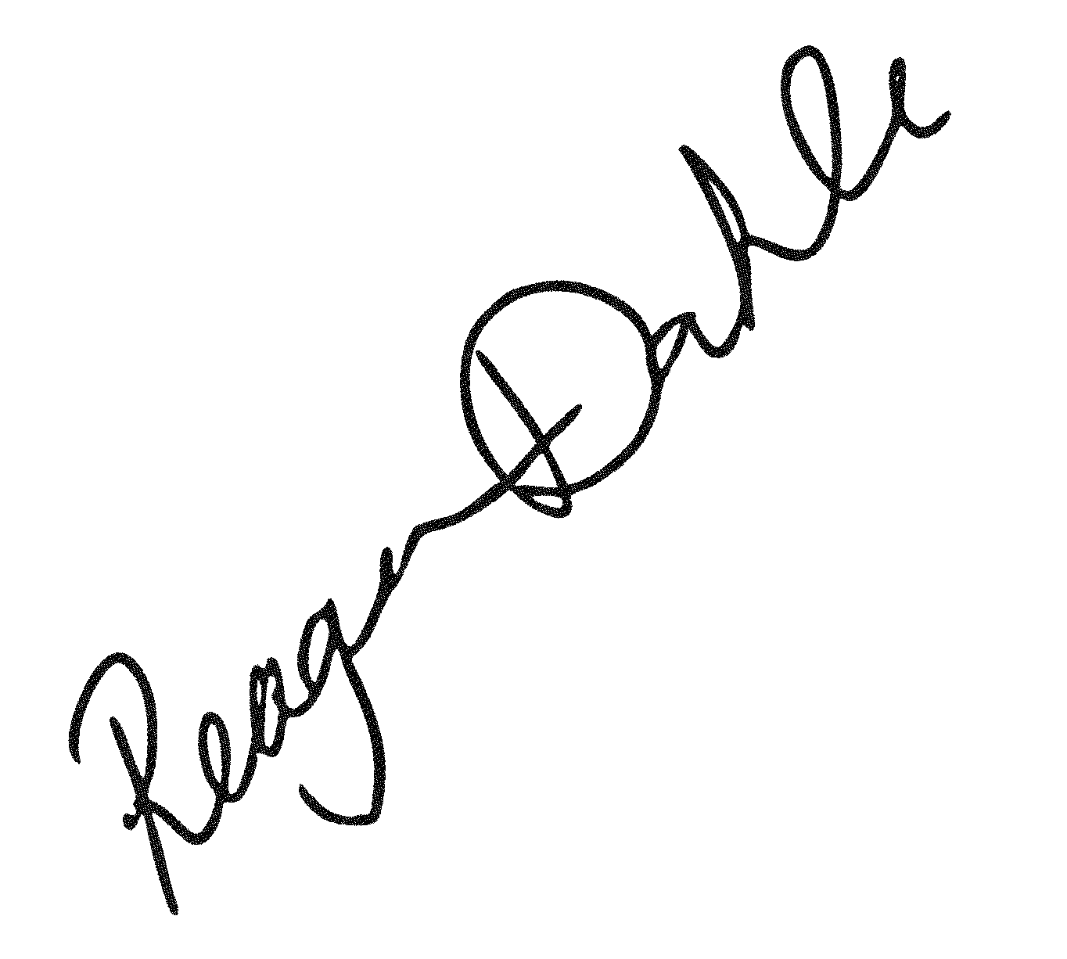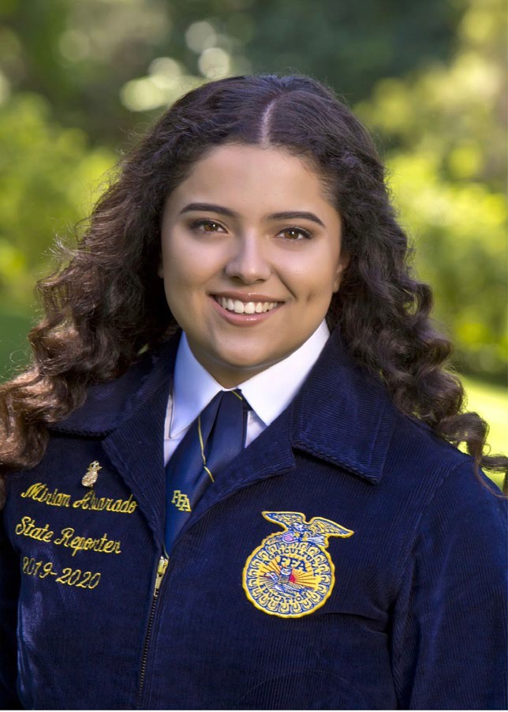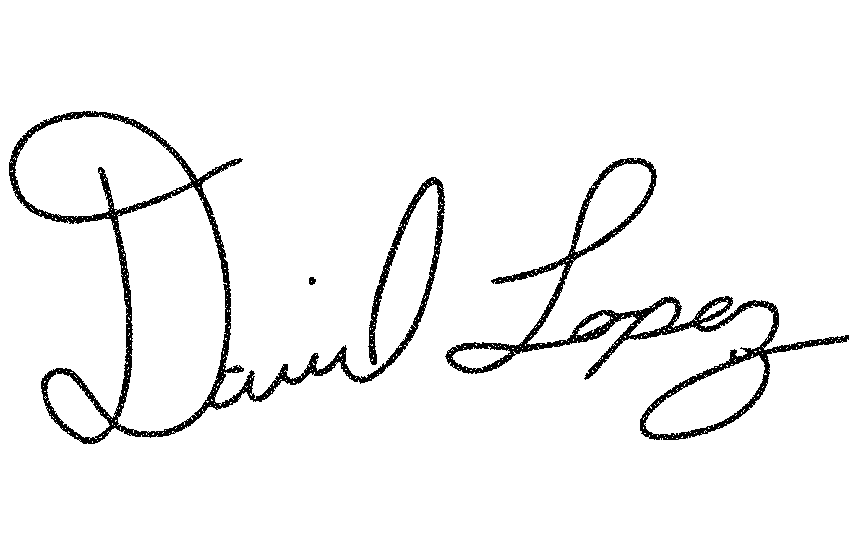

**Meet Your 2019-2020 State Officers**

Carlyn Marsh State President Arbuckle FFA

Reagan Dahle State Vice President Bieber-Big Valley FFA

Lindsey Swall State Secretary Tulare FFA

Miriam Alvarado State Reporter Lancaster-Antelope Valley FFA

Kayla Zalesny State Treasurer Nipomo FFA

David Lopez State Sentinel Holtville FFA

2

**Glossary**

3

**FFA**

Future Farmers of America used to be an organization dedicated to boys who were interested in pursuing a career in farming. Since 1928, the FFA Organization has expanded their membership to include students who are interested in all parts of agriculture including research, business, and all parts of the agricultural industry that help get our food from the farm to our table. In California, all students enrolled in an agricultural class are automatically considered FFA members.

**STATE CONFERENCE**

An annual conference hosted by the state officers where business is conducted, state awards are distributed, and FFA members provide a keynote message to all guests. This is typically held in a convention hall with over 6,000 students in attendance. For the 2020 year, state conference was held virtually due to COVID-19.

**STATE THEME**

Each year the state officers choose a theme for their state conference that guides the purpose and messages of each session.

**STATE OFFICER**

Each year 6 students are elected to serve as a state officer who represents all of the students in their state enrolled in agricultural class. These students must have their state degree and take a year off from college to fulfill their responsibilities.

**NATIONAL OFFICER**

National officers dedicate one year of service with the organization. The time is spent representing student membership during meetings with the National FFA Board of Directors, facilitating workshops that bring leadership and knowledge to FFA members, delivering motivational speeches and serving as advocates for FFA on a global scale.

**STAR AWARD**

The member must demonstrate outstanding achievement with their Supervised Agricultural Experience project, active **FFA** participation and an exemplary scholastic record.

**CHAPTER**

Your school… ex. Elk Grove High School is the Elk Grove FFA Chapter. IF your high school’s name is different of that of your town, it would look like this: Pierce High School in Arbuckle’s chapter would be called the Arbuckle-Pierce FFA Chapter

**SECTION**

Typically 5-15 schools in your county or nearby that meet to discuss local agricultural and FFA business. Ex: Sonoma FFA Section

**REGION**

There are 6 regions in California: Southern, South Coast, San Joaquin, Central, North Coast, and Superior. Each region selects winners in various contests and sends them to the state to compete against other regional winners.

**MIDDLE SCHOOL PROGRAM**

Not all FFA chapters have a middle school program, but some schools include middle school members in their FFA Chapter. These programs have an agriculture teacher who also teaches at the middle school.

**ADVISOR**

Your agricultural teacher is your advisor. Our Association and the State Officer team rely heavily on the guidance and wisdom of the many members of state staff, all who serve as advisors. This guidance helps local programs thrive and agricultural education disseminate through California.

**ALUMNI**

A graduate of an agriculture program and FFA chapter.

**SAE**

Your Supervised Agricultural Experience (SAE) is an agriculturally related project you complete outside of class where you start your own business, research improvements in agriculture, work for an agricultural company, or interning for someone in the industry.

**AGRISCIENCE**

The Star in Agriscience is awarded to the FFA member that demonstrates the top agriscience-based supervised agricultural experience in the state, including students who are actively engaged in doing



Directions: Complete this word search using the terms from above.

4

their own research individually, as well as those students who may be cooperating on research projects with others.

**AGRIBUSINESS**

The American Star in Agribusiness is awarded to the FFA member with the top nonproduction agribusiness supervised agricultural experience in the nation.

**AGRIPLACEMENT**

The American Star in Agricultural Placement is awarded to the FFA member with the top agricultural placement supervised agricultural experience in the nation.

**STAR FARMER**

The Star Farmer is awarded to the FFA member that demonstrates the top production agriculture supervised agricultural experience in the state.

**WEBPAGE AWARD**

The Web Site Development Award is to recognize those FFA Chapters that develop and maintain an effective chapter website.

**NATIONAL CHAPTER AWARD**

The **National Chapter Award Program** is designed to recognize FFA chapters that actively implement the mission and strategies of the organization. These chapters improve chapter operations by creating goals that emphasize growing leaders, building communities and strengthening agriculture.

**PROGRAM SIZE**

FFA programs vary in size. Some programs may only have one agricultural teacher while large programs can have up to 10 teachers.

**REPORTER**

An officer position that is responsible for publicizing chapter activities, writing articles for the local newspaper, maintaining the Chapter website and communication on social media. Chapter Reporters who do an outstanding job compete for the State Star Reporter Award.

**Video Scavenger Hunt**

To learn about the different FFA conferences you can attend, click on the link to the video explanation. Write a short description for each conference.

5

[FFA](https://vimeo.com/415479852)

[California State](https://vimeo.com/314044675) [Conference](https://vimeo.com/314044675)

[National FFA](https://drive.google.com/file/d/102HPOG1_wxYo5AShPC3vpqEiuXGJwHFt/view?usp=sharing) [Convention](https://drive.google.com/file/d/102HPOG1_wxYo5AShPC3vpqEiuXGJwHFt/view?usp=sharing)

[Career Development](https://drive.google.com/file/d/1FlKqnISmxURavTllJCXOPV-1cDxR7TC_/view?usp=sharing) [Events](https://drive.google.com/file/d/1FlKqnISmxURavTllJCXOPV-1cDxR7TC_/view?usp=sharing)

[WLC](https://www.ffa.org/conference/washington-leadership-conference-wlc/)

[SAE](https://www.youtube.com/watch?v=egEQVcnydKU)

[MFE](https://www.calaged.org/MFE) / [ALA](https://www.calaged.org/ALA)

[GLC](https://www.calaged.org/GLC)

Opening and Closing Ceremonies

[Spanish](https://drive.google.com/file/d/1UfD9euD1h10gWgdQFGbvGtry7wA9odrM/view?usp=sharing) [English](https://www.youtube.com/watch?v=AqjGSSBPNXI)

[The FFA Creed](https://drive.google.com/file/d/1UOadWYbb6141byAXAu1bO2npavLG-1cT/view?usp=sharing)

[Why is FFA Relevant?](https://drive.google.com/file/d/11y14LcPGTSa3SbMLfoC6SXz2pBsMpjvM/view?usp=sharing)

[What is the theme for](https://vimeo.com/428177315) [the Virtual State](https://vimeo.com/428177315) [Conference you are](https://vimeo.com/428177315) [about to watch?](https://vimeo.com/428177315)

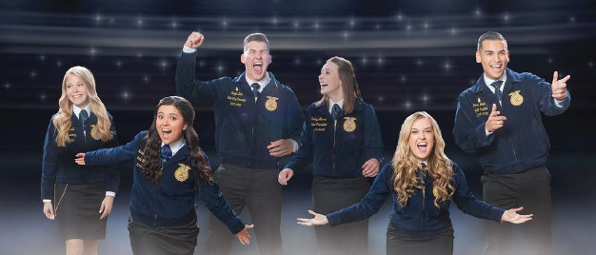

**6 ways to get the most out of this experience**

* **Treat this like the *real* thing!**Don’t be afraid to dance if you hear a song you love or cheer

for someone when they earn an award!

* **Get your *squad* in on the growth!** Ask your friends what they liked about the sessions!

❏

***Connect*** with people by following

**@californiaffa** and **#californiaffa** on Instagram

* **Keep *Growing*!** Don’t let the growth stop at the end of this conference. Use the reflect and practice sections of this workbook to help you

continue to practice leadership in your everyday life.

❏

***Engage*!** Don’t passively listen. This conference

has so much great material packed into 4 one hour

sessions.

7



**Theme** [**Presentation**](https://vimeo.com/428177315)

**Ready to check out more? LET’S GO ALL IN TOGETHER!**

8

**Activity 1:**

What “futuristic trend” did the team do to go ALL IN?

What two skills did the instructors use that we could also use in our Supervised Agricultural Experience projects?

**Activity 2:**

What wild thing did the team do for their second ALL IN activity?

What can we get involved in that will help us feel that same sense of victory like diving over the wall?

**Activity 3:**

What activity did the team do to go ALL IN on that would allow them to do some good?

What are some ways in FFA that we can live a life of service?

What is a “Theme” and what is the purpose of FFA having themes each year?

[**Session 1**](https://vimeo.com/430801177)

**All In**

**Opening Ceremonies**

**Directions**: During Opening ceremonies, capture down the symbolic item that each officer is stationed next to.

How many FFA members in California are able to watch the virtual celebration?

**New Chapters**

Who are the 3 new FFA Chapters?

1.

2.

3.

What would you tell a student who has no idea what it means to take an agriculture class?

9

**Office**

***Stationed by the..***

Sentinel

Reporter

Treasurer

Secretary

Advisor

Vice-President

President

**Prior to the session:**

When you think of an FFA member, what comes to mind?

**State FFA Advisor Remarks**

Who is the State FFA Advisor?

What does going ‘All In’ mean to you?

**National Officer Keynote**

*National officers dedicate one year of service with the organization. The time is spent representing student membership during meetings with the National FFA Board of Directors, facilitating workshops that bring leadership and knowledge to FFA members, delivering motivational speeches and serving as advocates for FFA on a global scale.*

10

**Pause and Respond**

How would you define success?

What is something you are passionate about and why?

**Press Play: National Officer Keynote**

Where is Yomar Roman Negron from?

How were the ants able to move the candy so quickly?

Who are 3-5 people in your life that have supported you?

Spanish Translation *“We are greater together than the sum of our parts. 1+1=3.”*

**Delegate Recognition:**

How many students serve as delegates from each chapter?

How many committees were there?

*Purpose of Committees: These committees are led by students so that changes in FFA can be initiated here.*

11

Spanish Translation “*Don’t be ashamed of your ability to speak 2 languages, even if they aren’t perfect. Just like there isn’t a one size fits all show for every occasion, language is the same way, it’s better to have 2 than just one. Language unites us more than it separates us. Be proud of who you are, where you come from, the culture you represent and remember that our differences are our most valuable assets. Be an example to others so that they will feel better about showing and living who they reality are instead of putting on a persona that isn’t them.”*

Why do you think that Yomar chose to speak in Spanish to deliver that message?

**Pause and Reflect**

What is something you want to be ‘All In’ on? How will you do that?

What are traits in people that you look up to and why do you admire those traits in them?

Yomar mentioned that it is the effort of many that helps us be successful. What is something we can accomplish if we work together more often?

**Directions:** Draw a line for the committee to its correct description as each committee is being recognized.

Evaluated applications for a myriad of state FFA opportunities, award programs, and scholarship opportunities.

Awards Committee

Expansion of Middle School Opportunities Committee

Suggesting experiences where students learn about agricultural careers.

Student Resources for AET Committee

Discussed improvement of CA current CDEs.

Created to assess current SAE opportunities and suggest new educational recognition opportunities.

Expansion of Local Alumni Engagement Committee

Discuss the type of resources students would need to operate the online Ag Experience Tracker.

The Expansion of SAE Opportunities Committee

Suggesting new opportunities for middle school members to participate in CA FFA Discuss how to keep local alumni engaged in FFA.

FFA Application Committee

Designed to select winners for state award programs.

Student Exposures to Agricultural Careers Committee

**State Officer Retiring Address**

*A retiring address is a message given by one of the State FFA Officers about something that they are passionate about and guide listeners to develop their leadership. They are introduced by friends and family, share pictures to allow you to see into their childhood, and a slideshow of their year as a State Officer follows their speech. State Officers live together, take a year off from college and travel the state and nation in the course of their work. At the end of their year as they deliver their message, they can sometimes be emotional.*

Why would a State Officer be emotional sharing their retiring address message?

Why would a State Officer’s teammates be emotional in their recognition of one another?

What is something you’re so passionate about you could be emotional when discussing?

12

*Alright! Let’s check out David Lopez’s retiring address…*

13

**Pause and Respond**

What does it mean to be authentic?

List 5 things that make you unique:

**Press Play: Something More**

What are some things that David loves?

How did David do in Creed and BIG?

What did David do to be successful?

Who is Chuy?

Who is Cole?

What did the Galt Varsity Soccer Team remind David?

What are the 3 things David mentions are important to be successful?

**Authentic**

Noun /kə- /ôˈTHen(t)ik/

**Sponsors:**

*Western States Petroleum Association helped make this virtual conference possible!*

Who is President of WSPA?

After looking them up online… describe what WSPA does below:

Why would WSPA choose to financially support FFA?

14

Spanish translation: “*I am Mexican and proud of my culture. This doesn’t dictate what I can do, however just expands the opportunities that are open to me. We all belong together and we should keep doing our best to make our families proud by being our authentic selves.*”

Why do you think that David spoke this part in Spanish?

*“Seek to understand that who you are is enough.”*

**Pause and Reflect**

What does it mean to accomplish something?

David shared “Give your all to your work, in your own skin, in your own way.” What does this mean to you?

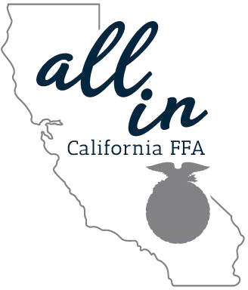

**Big picture thinking:**

15

**YOUR TURN: Identify ways you can implement these values in your everyday life. Practice:** What are ways you can help others be true to themselves? List 3 examples and how you can implement them this week.

●

●

●

**Practice:** What are ways you can add value to this FFA Chapter by being your unique self? Identify 3 examples and how you can implement them this week.

●

●

●

[**Session**](https://vimeo.com/430821317) **2**

**National Officer Keynote**

*National officers dedicate one year of service with the organization. The time is spent representing student membership during meetings with the National FFA Board of Directors, facilitating workshops that bring leadership and knowledge to FFA members, delivering motivational speeches and serving as advocates for FFA on a global scale.*

16

**Pause and Respond**

What do you think of when you hear the words: School, FFA, vegan? Positive or negative? Why?

**Press Play: Mamie Hertel**

Where is Mamie from?

What place did she get in her Creed contest? Who did Mamie meet during her calculus class? What was really bothering Mamie?

How did Mamie react to hearing that her parents were getting a divorce? Who was she thinking about?

**Pause and Reflect**

Have you ever experienced loss at a sport or contest in your life? How did you react? How did that make you feel and how did you get through it?

How would life look different if we started moving toward a goal TODAY. What would life look like 3 months from now?

**School and Advisor Recognition**

17

**What type of programs did these officers come from? What words did they use to describe their schools and their agriculture teachers?**

Did you know that there are different size FFA programs? We classify them into 3 categories based on the # of agriculture teachers:

1 person

2-3 person

4 or more

**Pause and Reflect**

What role do your teachers/coaches play in your life?

Have you ever judged someone before we truly know who they are? What if we didn’t do that? How would that change our lives, communities, world?

We don’t have control over what happens to us, but we always have control over how we react to what happens. What does this idea mean to you?

**Star Awards:**

18

**BEFORE YOU START**

**What are the awards and what are the qualifications to get them?**

1. **Reporter:** Chapter Reporters who go above and beyond in the world of journalism; including print media, radio broadcast, television broadcast, recruitment programs etc.
2. **Administrator**: Administrators that go above and beyond to help their chapter excel
3. **Counselor:** Counselors that go above and beyond to give their students opportunities at the middle school or high school level.
4. **Supporting Staff**: Continuously encourage and foster the growth of their FFA chapters, while making sure that students are highlighted and supported.
5. **Golden Owl**: Agriculture Educator of the year. Teachers who show competence and engagement at their local levels

**While you watch:**

If you were to submit your chapters entry for these categories, who would you recommend? Write your answer in each star.

When is the last time you thanked them for the work they have done on your behalf? *Ex. stayed late to help you, driven you to a contest, given up time before, after and during lunch to help you with something.*

Now is the time to do that very thing. In the space below, lay out a sample thank you note that you would write to a teacher or coach who has gone the extra mile!

Happy with the draft? Now make one for real. Even if it’s on binder paper. � After giving them their thank you note… what effect do you think it has on them? Why would that be the case?

*Reporter*

*Supporting Staff*

*Administrator*

*Golden Owl (FFA*

*Advisor)*

*Counselor:*

**In summary:**

Choose two of your potential nominees. What have they done that would cause you to nominate them?

19

**(See Stars below to answer questions)**

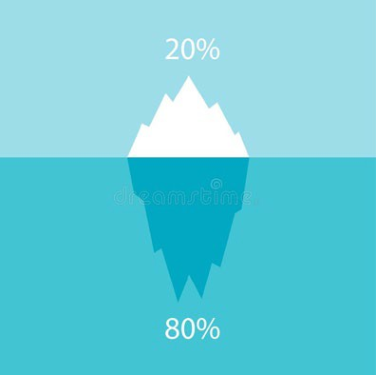

**State Officer Retiring Address**

*A retiring address is a message given by one of the State FFA Officers about something that they are passionate about and guide listeners to develop their leadership. They are introduced by friends and family, share pictures to allow you to see into their childhood, and a slideshow of their year as a State Officer follows their speech. Check out Miriam Alvarado’s retiring address.*

20

**Pause and Respond**

Do you have any favorite quotes or mantras?

What are the first things you notice about someone when you first meet them?

How would you define kindness?

**Press Play: Kindness Counts**

What kind of small choices made Miriam as a 6th grader feel like she belonged?

Miriam talks about those kind choices being the “1st cracks in the dam” that ultimately changed the way she saw herself. What does this mean?

Step 1:

What is a leader’s most transformative tool?

What is one way you could choose kindness every day?

21

Step 2:

What is meant by the term “selective kindness”? Why would it be something worth addressing?

What did Miriam experience that gave her a chance to break her routine of being selectively kind?

How did she eventually connect with that student?

What advice did Miriam give the student who said he was lonely?

How can we start choosing kindness as soon as the video ends?

What is the one thing that really counts?

**Pause and Reflect**

Do we ever shut out people by using those short responses? How do we make others feel when we answer in that way?

What is dignity? What are some ways we can treat someone with dignity?

**Sponsors**

22

**Optional Practice**

Identify 4 ways you can include small acts of kindness in your daily or weekly routine. List and describe them below:

Why should leaders like you go all in with kindness?

**Devin Furman- Nationwide Sponsor**

What award did Nationwide sponsor this year?

**Jamie Johansson - California Farm Bureau President**

What does the California Farm Bureau do for the agriculture industry?

When is the last time you shared your kindness with someone who needed it? Why might some of us be less willing to share our kindness?

[**Session 3**](https://vimeo.com/430811801)

**State Officer Retiring Address**

*A retiring address is a message given by one of the State FFA Officers about something that they are passionate about and guide listeners to develop their leadership. They are introduced by friends and family, share pictures to allow you to see into their childhood, and a slideshow of their year as a State Officer follows their speech. Check out Kayla’s retiring address.*

23

**Pause and Respond**

Do some searching on “Circle of control”. What does that mean?

How do you normally handle setbacks?

How can attitude play a role in how we handle setbacks?

**Press Play: Laugh & Learn**

What are your immediate thoughts/reactions when things go wrong for you?

Where did Kayla vow to never take any moments for granted again? Why do you think she chose that spot?

What difficult decision was presenting itself before Kayla?

24

Why did Kayla decide to attend her contest?

What 2 things was Kayla going to go all in for?

1.

2.

Kayla made a mistake at her county fair that resulted in her entire group being disqualified, how did she handle her mistake?

What allows our brains to function at peak capacity?

*“In order to move forward, we should stop seeing things as obstacles and instead see them as opportunities for growth.”*

**Pause and Reflect**

What are some moments that you have taken for granted?

What if we saw our problems as opportunities instead of setbacks?

**Optional Practice:**

How could our lives change or look different if we embraced Kayla’s perspective on life?

**National Chapter Award and Website Development Award**

25

**While you Watch:**

Who won the National Chapter Award this year? Where are they located? Region?

What are the 3 criteria for an award worthy website? 1.

2.

3.

Who won the webpage contest?

**After you watch:**

If you were in charge of making the list of great things that your chapter does for the description of this award, what kinds of things could you say about your chapter?

**WEB SEARCH**

Go explore one of the winning chapters websites and list 3 things you like about it.

1. Arbuckle-Pierce <https://arbuckleffa.wixsite.com/arbuckleffa>
2. Brawley <https://sites.google.com/brawleyhigh.org/brawleyffa/home>
3. LeGrand <https://www.legrandffa.org/>
4. O'Neals-Minarets <https://discoverminaretsff.wixsite.com/minaretsffa>
5. Santa Maria-Righetti <https://www.righettiffa.org/>
6. St. Helena <https://sthelenaffa.wixsite.com/shffa>

What are some ways your chapter could replicate some of the elements of the winning webpage to improve your own site? If you don’t have one, what are some key elements you could include in yours?



**Star SAE Projects:**

**Star in Agriscience:**

Highlight the winner and cross off the descriptor about the project that isn’t true!

26

**Emily Sarantopoulos**

*Elk Grove FFA*

-Pesticide influence on soil profile

-Canned tomato preservation

-Market rabbit weight gain

**Sam Norgove**

*Healdsburg FFA*

-Density of yeast fermentation in temperature creep

-Orchard grass growth rates

-Brewers grain being used for feed rations for pigs

-Analyzing # of students in ag classes who come from ag background

**Before you Start:**

What are these award Categories

1. **Agriscience**
2. **Agribusiness**
3. **Agriplacement *Winners each get***
4. **Star Farmer *$10,000 for their***

**While you watch: *work!***

Mark who won each category.

**After you Watch:**

If you had to choose to continue the work of 1 project from all categories, what would you choose and why?

Which of the projects was most surprising to you?

If you could start any SAE (it doesn’t have to be in the video…) and finances weren’t a factor, what would you want to pursue?

**C*heck out more to start your own creative SAE!***

<https://saeforall.org/sae-for-all-program/?wizard>

*If you were to start your own Agriscience research project, what would you do it on?*

**Star in Agribusiness:**

Highlight the winner and make a quick description about their project:

*If you were to make your own Ag business, what would you want to sell?*

27

**Alyssa Laredo**

*Merced FFA*

**Haylee Hoffman**

*Dixon FFA*

**Nicholas Mello**

*Hanford FFA*

**Zach Alves**

*Paso Robles FFA*

**Clayton Guy**

*Pine Valley-Mountain Empire FFA*

**Max Myers**

*Arbuckle-Pierce FFA*

**Makenzie Camacho**

*O’Neals-Minarets FFA*

-Testing of rinsing fruit and veggies to remove bacteria with tap water

-Fungus botryosphaeria in walnuts

-Surveyed consumers about results of taste test with different almond varieties

**Dean Hill**

*Templeton FFA*

-Finding a way to protect plants and prevent damage from pests using chemicals

-Using rodents to sniff out rare fungi in flowering plants

**Emma Thorpe**

*Lakeside-El Capitan FFA*

-Bacterial inserts for stone fruit tree growth

-Comparison of different pasteurization for mozzarella cheese productions

-Pasteurization vs Homogenization in cheese making

-Ultraviolet light radiation and Effects on bacteria counts on meat

**Lindsey Degraff**

*Marysville FFA*

-Preferred methods to preserve pumpkins

-TikTok’s influence on consumer purchasing behaviors

-Colored genes in naturally colored merino sheep

**Star in Agricultural Placement:**

In the boxes below, draw or insert an icon that you believe best represents the finalist’s project!

*If you were to work in a segment of agriculture, which industry area would you want to work in?*

**Star Farmer:**

*Write down one cool thing each finalist does in their project that you could learn from.*

28

**Peter Bliss**

*Merced-Golden Valley FFA*

**Austin Maners**

*Sebastopol-Analy FFA*

**Hannah Mancebo**

*Chowchilla FFA*

**Sarah Brewen**

*King City FFA*

**Irelyn Bese**

*Merced-Golden Valley FFA*

**Kiley Andersen**

*Sebastopol-Analy FFA*

**Deyvet Carbajal**

*Madera South FFA*

**Mark Doss**

*Nipomo FFA*

**Trevor Herman**

*Ramona FFA*

**Matthew Thunen**

*Sutter FFA*

*If you were to start a new project in agriculture, what would you want it to be on? Dream big!*

**State Officer Retiring Address**

*A retiring address is a message given by one of the State FFA Officers about something that they are passionate about and guide listeners to develop their leadership. They are introduced by friends and family, share pictures to allow you to see into their childhood, and a slideshow of their year as a State Officer follows their speech. Check out Lindsey’s retiring address.*

29

**Pause and Respond**

Do your fears hold us back? What are they and why?

Do we sometimes assume the worst in others? Why?

**Press Play: The New List**

What does it mean to be a “task master”? How do you handle big tasks?

What could Lindsey have focused on instead of hiding behind productivity?

What does Lindsey's new list look like?

**Elise McKinsey**

*Valley Center FFA*

**Josh Albrecht**

*Chico-CORE Butte FFA*

30

What was Lindsey's true fear?

What role did Mr. Koelewyn play in Lindsey's life?

What was Mr. Koelewyn’s wish for Lindsey that she never got to show him?

What does she regret about how she handled herself around him?

Why did Lindsey eat lunch alone every day?

What story did she tell herself in order to justify this path of loneliness?

What is the biggest lesson Lindsey learned this year?

What could be the result if we don’t let people into our lives by seeking discomfort and being open?

How close is our new authentic life according to Lindsey?

**Pause and Reflect**

Is there anyone we work with often that we never really let in?

Is there a relationship/friendship in your life that isn’t as strong as it once was? Why could that be?

**Sponsors Activity**

31

**Before you Watch:**

What is a sponsor?

Why does it make sense for them to invest in the FFA?

What do companies get out of supporting the FFA?

What are some examples of the benefits they receive from their investment?

**While you Watch:**

What companies are mentioned that support the FFA?

Do you recognize any names of companies that are supporting the FFA?

**After you Watch:**

**WEB SEARCH**

From the list of sponsors below, search two of them and write a quick description of the work they do and what career options someone might have with them.

**Sponsor List:**

1. California Farm Bureau
2. Petersen Caterpillar
3. Holt Caterpillar
4. Quinn Caterpillar
5. Hawthorne Caterpillar

Only when we are uncomfortable do we do the most growing. What does this quote mean to you?

As you look ahead at the future of your life, what do you see is the biggest benefit to being vulnerable and putting relationships first?

32

**National Chapter Award Challenge (Optional Post Activity)** Research the National Chapter Award. What are the main qualifiers for this award area?

What are some things on the list your chapter does really well?

What are some things on the list your chapter could improve upon?

What would it take for your own chapter to be a prime candidate for National Chapter Award? What steps can we take to move toward that goal?

What is one activity you already do in a typical year that could be revised to improve your chances of winning the National Chapter Award? How would you revise it?

1. Think Big Program at San Joaquin Delta College
2. Universal Technical Institute
3. Ag Source Magazine
4. Western States Petroleum Association
5. Harris Ranch
6. Farm Credit
7. Assemi Group Research Results:

[**Session 4**](https://vimeo.com/431013017)

**State Officer Retiring Address**

*A retiring address is a message given by one of the State FFA Officers about something that they are passionate about. They are introduced by friends and family, share pictures to allow you to see into their childhood, and a slideshow of their year as a State Officer follows their speech. Check out Reagan Dahle’s retiring address.*

33

**Pause and Respond**

How would you define “Pride”

What are you proud of?

Who are you grateful for?

“Work is a blessing.” Why would you consider this true?

**Press Play: Take Pride**

What is Reagan's family’s business?

What did Reagan’s dad teach him?

What is Angel’s SAE?

**PRIDE**

Noun /prīd/

satisfaction derived from one's own achievements.

34

What did Reagan learn from Angel?

What do we have in common with the characters in the books that Reagan talks about?

**Pause and Reflect**

Reagan mentioned that he resented working for his family's business until his dad helped change his perspective. Are there things we resent without fully understanding them? What is an example of this in your life?

What are things about your family that you are proud of?

Are you proud of the people that provide for you? Do you show it?

What are some things about yourself you are proud of?

35

**Family Recognition**

Family looks different for everyone. Who are your family members?

How would your life look different if your family wasn’t there for you?

What would you want to thank your family for if you wrote them a letter just to thank them?

When was the last time you appreciated your parents and family out loud? *How* can you show your appreciation to your family right now? (letter, email, card)

**Nominating Committee Recognition**

*In 2020, 80 candidates applied to be a state officer and dedicate a year of service to California FFA. A nominating committee chaired by the immediate Past State FFA President and made up of 2 current members from each region develops an interview process to narrow down the pool of applicants to a slate of*

*12. They use the qualities they believe make up the most effective leaders to guide their process.*

If you were on the Nominating Committee, what is one quality in a leader that you would be looking for? Why?

*Fun Fact:*

*Slate- A list of individuals who are running for officer positions. Ex: Chuy is slated against Angel for President*

**State Officer Retiring Address**

*A retiring address is a message given by one of the State FFA Officers about something that they are passionate about. They are introduced by friends and family, share pictures to allow you to see into their childhood, and a slideshow of their year as a State Officer follows their speech. Check out Carlyn Marsh’s retiring address.*

36

**Pause and Respond**

How would you define community?

What comes to mind when you think of your community?

**Press Play: Communities Around Us**

How does Carlyn describe community?

Who was the catalyst for helping Kurt?

Adrian won an award at the Greenhand Leadership Conference. What did Ben do?

What has Carlyn found to be the most important thing students gain from FFA trips?

**Community**

No un /kə- ˈmyü-n ə-tē/

**Retiring Address Wrapup**

Which retiring address did you find spoke most to you? Why?

Describe the retiring address message that you think the people around you need to hear most. Why?

37

What does Carlyn share can happen with absence of community?

*“We must be the ones to ensure that doesn’t happen. Everyone needs community.”*

**Pause and Reflect**

How do you celebrate your friend’s victories?

What is the foundation for a strong, long lasting community? How do you strengthen your community?

What could cause someone to feel like they lack community?

Who do you know that needs a community? What can you do to invite them into yours?

38

**Your Turn:**

The State Officers shared reasons they are thankful for their families. After class, send a text to your family telling them that you appreciate them and why you are grateful for them. Pay attention to how they respond and how you feel sending that text.

Carlyn talks about the importance of community. Not everyone has a community. This week, invite someone into yours. How did that person react to your invitation? How can you welcome people into your community more often?

**New Team**

*The 2020-2021 State officer team was elected in May by 700+ delegates from across the state. These 6 students will serve as State officers for the 2020-2021 year and will travel to chapters across the state.*

Match the newly elected State Officer with their position:

Of the quotes, choose one and explain how this applies to you personally or to your chapter.

“As you meet people this year, learn to meet them where they are and grow alongside them.”

“Remember your smallest choices of kindness can be transformative”

“Never forget to laugh and learn through the journey that awaits you.”

“Challenge yourself to face your fears and be open with others.”

“Take pride in the work you do and know that an impact will be made.”

“Invest yourself in the communities around you and work to create new ones for others.”

President Taylor Sollecito Vice President Reese Gonsalves

Secretary Dean Hill

Treasurer Maico Ortiz

Reporter Emma Thorpe

Sentinel Mia Arisman

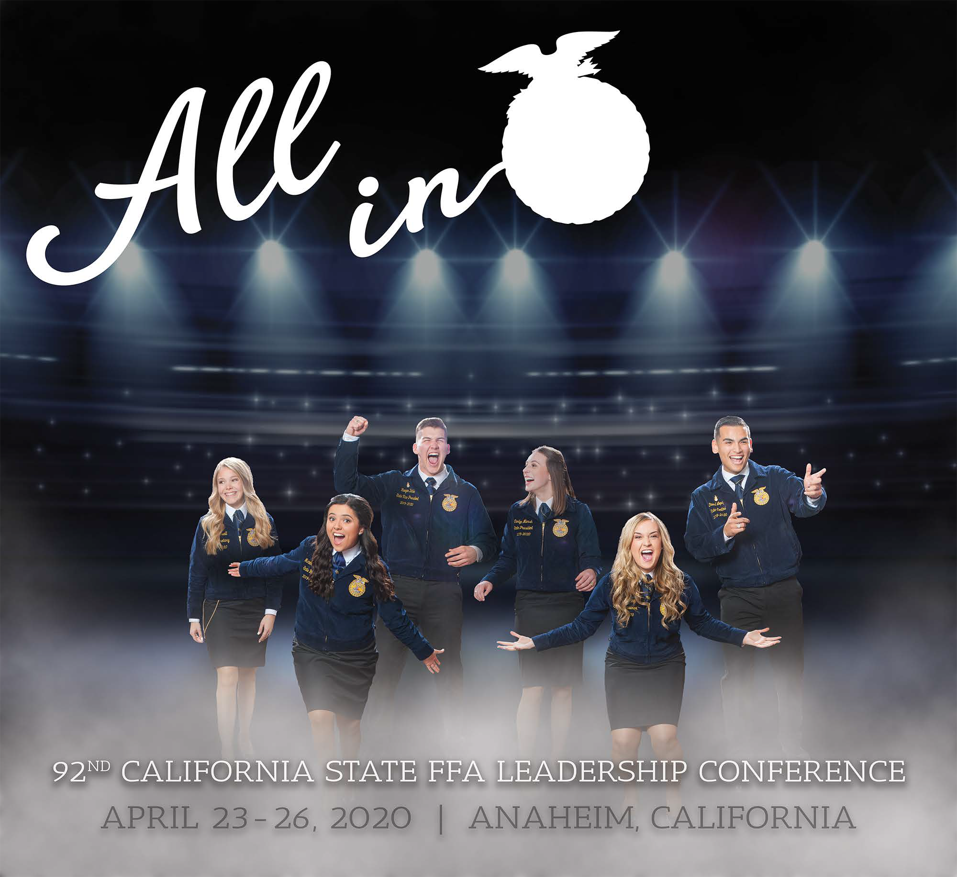

*Thanks for tuning in! We hope you have been given, even in small ways, the ability to go all in and become the best person, FFA member and leader you can be!*