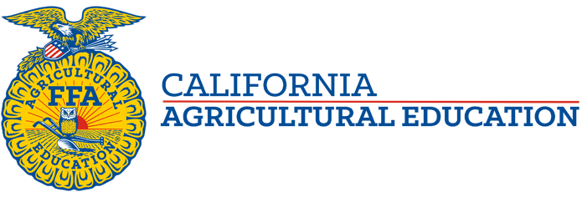

Congratulations to all competitors on a successful National FFA Convention! Here are a few highlights of California’s 2020 Convention experience…
National Officer Election
David Lopez, Holtville FFA, National Western Region Vice President
Video: https://vimeo.com/473673400
Agriscience Fair Results
Animal Science Division 6 – 3rd Place Danae Westra & Ryan Bleeker, Visalia-CVC
Environmental Sciences Division 4 – 1st Place Isabella Albiani & Isabelle Alves, Elk Grove
Environmental Sciences Division 5 – 2nd Place Mackenzie Camacho, O’Neals-Minarets
Food Products & Processing Division 3 – 1st Place Mia Gillum, Hanford
Food Products & Processing Division 4 – 2nd Place Abigale Jacobsen & Olivia Renzullo, Elk Grove
Food Products & Processing Division 5 – 1st Place Liesl Wolf, St. Helena
Power, Structural & Technical Systems Division 3 – 3rd Place Colin Manfredo, Sanger
Power, Structural & Technical Systems Division 4 – 1st Place Sophia Albiani & Eden Hamming, Elk Grove

California had 4 National Winners in Agriscience Fair, tying the record set in 2008 for the most National Winners.

Proficiency Award Results
Ag Mech Design/Fabrication – Cole Marchy, Turlock
Ag Sales Entrepreneurship – Alyssa Laredo, Merced
Beef Entrepreneurship – Hunter Aue, Merced-Golden Valley
Environmental Science – Spencer Stephens, Merced-Golden Valley
Equine Science Placement – Deyvet Carbayal, Madera
Fiber and/or Oil Crops – Peter Bliss, Merced-Golden Valley
Nursery Operations – Abigail VanKlaveren, Modesto
Sheep Production – Madison Woods, Gustine
Specialty Crop Production – Eric Quezda Ridge, Nipomo

California had 9 National Winners in Proficiency, breaking the record set in 2007 when California had 7 National Winners.
Congratulations to all on a great National FFA Convention!

