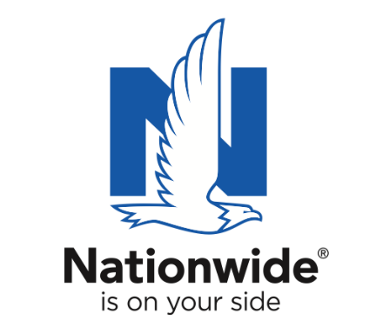
FOR IMMEDIATE RELEASE

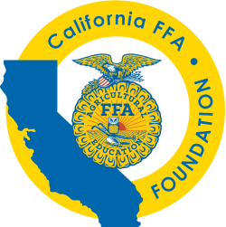
June 28, 2021

Contact:
California FFA Foundation
Maureen Funk
209-969-5065
mfunk@californiaffa.org

Nationwide
Graham Shippy
614-249-0682
shippg1@nationwide.com

Nationwide Honors Six California Agricultural Teachers, Names 2020-2021 “Ag Educator of the Year”

Eureka High School’s Sandy Lovfald selected as California’s
Golden Owl Award® grand prize winner and “Ag Educator of the Year”

Des Moines, IA – Agricultural teachers play an essential and selfless role as they work to prepare future generations for successful careers. After recognizing six exceptional California teachers as finalists through the Golden Owl Award, the California FFA, in partnership with Nationwide and the California Farm Bureau, selected Sandy Lovfald, agricultural teacher at Eureka High School, as California’s 2020-2021 “Ag Educator of the Year.”

Lovfald was formally recognized as the Golden Owl Award grand prize winner during the broadcast of the California FFA State Leadership Conference in Sacramento. In addition to the title of California’s Ag Educator of the Year, Lovfald received the coveted Golden Owl Award trophy and a $3,000 Nationwide-funded donation to further Eureka High School’s agricultural education efforts.

Nominations described Lovfald as hardworking, dedicated and well respected within the agricultural education community. One nomination read, “While in high school, I had no plan to continue my education after high school. I didn’t think I was capable. With the support of Mrs. Lovfald, I found a passion for agriculture and understood the importance of pursuing higher education. I went on to graduate from my dream college and I’m now an ag teacher myself! My goal in life is to have as big of an impact on my students as she did on me.” Another one stated, “She is the most selfless person I know. If she hears you need somebody to talk to she’ll be listening in a heartbeat. She is so kind to everyone no matter what kind of day she’s having. Ms. Lovfald has taught me so many life lessons through agriculture.”

As the number one insurer of farms and ranches in the United States¹, Nationwide established the Golden Owl Award with its state partners to shed light on the contributions of California’s leading agricultural teachers and provide additional resources to support their programs.

“With deep roots in agriculture, Nationwide is proud to recognize the men and women who are making a difference in our communities as they help students pursue their passions,” said Brad Liggett, Nationwide’s president of Agribusiness. “We’re honored to recognize the contributions of teachers, highlight the growing need for their services, and supply additional resources to help provide students with optimal learning experiences.”

Nationwide supports the future of the ag community through meaningful sponsorships of national and local organizations. In conjunction with the Golden Owl Award, Nationwide is donating $5,000 to each participating state’s FFA, including the California FFA, to further support the personal and professional growth of students, teachers and advisors alike.

The Golden Owl Award is the result of a partnership between Nationwide, the California FFA, California Farm Bureau, Illinois FFA, Illinois Association of Vocational Agriculture Teachers, Farm Credit Illinois, Indiana FFA, Farm Credit Mid-America, the Iowa FFA Foundation, New York FFA, New York Farm Bureau, Ohio FFA, Ohio Farm Bureau, Pennsylvania FFA, Pennsylvania Farm Bureau and Compeer Financial.

For more information, visit www.goldenowlaward.com.

¹ Source: A.M. Best Market Share Report 2019

About Nationwide
Nationwide, a Fortune 100 company based in Columbus, Ohio, is one of the largest and strongest diversified insurance and financial services organizations in the U.S. and is rated A+ by both A.M. Best and Standard & Poor’s. The company provides a full range of insurance and financial services, including auto, commercial, homeowners, farm and life insurance; public and private sector retirement plans, annuities and mutual funds; banking and mortgages; pet, motorcycle and boat insurance. For more information, visit www.nationwide.com.

