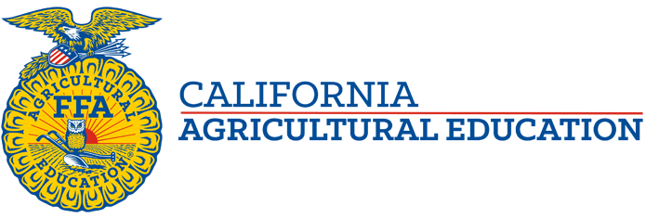

North Coast Region Tour, Vlog and Curriculum
The State FFA Officers recently toured the Redwood Coast of California, experiencing the natural beauty of our state's far northwest and soaking up the innovative practices of the region's agriculturists. Check out their vlog and the instructional worksheet to see what's happening in one of our most unique areas!

Video Link: https://vimeo.com/465106874

Curricular Resources:

