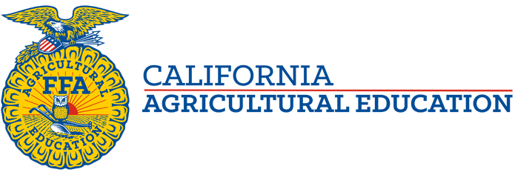

Superior Region Tour, Vlog and Curriculum
Recently our State FFA Officer team visited the far Northeastern corner of California, a remote and rugged portion of the Superior Region. With visits to FFA chapters and industry partners alike, we are grateful to have spent time in this beautiful part of our state. See below for the video link and for the instructional worksheets!
Video link: https://vimeo.com/480093482

Curricular Resources:
