

September 10, 2024

To: FFA Chapter Advisors

From: Charles Parker, State Supervisor and State FFA Advisor

Subject: Chapter Advisor’s Relationship with Section/Region Officers

Often it appears that the advisors of FFA chapters labor under the misconception that they have no jurisdiction or responsibility for the performance of members of their chapters who have been elected to serve as a sectional and/or regional FFA officer. The fact is, however, that there should be no difference in their relationship with officers at these levels than with their local chapter officers.

The situation is confused somewhat by the introduction of a new advisor, the sectional or regional advisor. This person is typically an agricultural teacher designated to serve in this capacity or the regional supervisor of agricultural education. Perhaps this confusion can be alleviated if we understand that sectional and regional advisors serve mostly to provide continuity and smoothness to the operation of sectional and regional levels of FFA.

The chapter FFA advisor who has a sectional or regional FFA officer on their chapter’s leadership roster should not feel supplanted in any way. Personal assistance received by the sectional or regional FFA officer to help them in their responsibilities will come almost always from the local chapter advisor. The officer who does not receive support and assistance from their chapter advisor cannot be effective in their role as a sectional or regional officer.

The scattered opportunities they will have to meet and work with their sectional or regional advisor will be too few for effective training. The sectional or regional advisor will concentrate on the mechanics of the activities. The advisor will expect that the officers will be elected based on their qualities and that they will have the necessary support and assistance from their chapter.

Participation as a sectional or regional officer will be a unique and valuable experience. Its value will be as an opportunity to practice and hone leadership competencies acquired under the direction of the local agriculture teacher and to prepare for future opportunities to serve.

Functioning as a sectional or regional officer is nothing more than another, different experience in a student’s total FFA career. Certainly, it is an honor for members and for their chapter for them to be selected to serve in such a leadership role. Still, they do so as a student in a particular agriculture department and as a member of that department’s FFA chapter. Their personal FFA advisor continues to be the chapter’s advisor.

Often, in the excitement and rush of participating as a sectional or regional officer the FFA members forget that they are responsible to their local chapter and school. The sectional and regional advisors will remind them of this, but in most cases, it will also be necessary for their chapter advisor to remind them.

One very practical, and perhaps difficult, example of the sectional and regional officers’ responsibility to their school is the need for them to observe its regulations and policies related to student absence from class and travel out of the district to fulfill the duties of the office. The chapter advisor owes it to the members (and to themself) to make certain that they are aware of and operating within the constraints of current district regulations and policies. It is important that the sectional and regional officer has in their possession written approval on the school letterhead leaving their school for the day.

To sum up, FFA members who are serving as sectional or regional officers do so under the auspices of their school, agriculture department, and FFA chapter. They remain subject to the regulations and policies of their school. Particularly as they relate to absence from class, traveling while representing the school, and eligibility to participate in school activities. The officer requires the support and assistance of their agriculture teacher to be effective in fulfilling the responsibilities of their office. The experience as a sectional or regional FFA officer will be unique, educational, and stimulating as the officer prepares for their career in agriculture.

Sincerely,

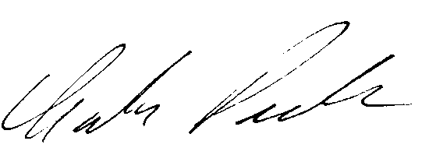

Charles Parker, Program Manager and State FFA Advisor

Agricultural Education & Family and Consumer Sciences Office

Career and College Transition Division

California Department of Education

[cparker@cde.ca.gov](mailto:cparker@cde.ca.gov)

(916) 835-4528 (Cell)